CS 566A3 Midterm Assignment
Due Oct 26 6:00 pm
Instructor: Dr. Belyaev

All work must be your own. Write your answers on these pages and show your work. If you feel that a question is not fully specified, state any assumptions you need to make in order to solve the problem.
Upload your answers on the blackboard to MidTerm Assignment in the CS566_A3 course site under assignments.
No extensions or late submissions for anything other than major emergency

Write your name and ID on this page.
Name Joseph Rissman
Student ID U09545917

Answers begin on next page.

Problem 1 [ 20 pts]
Given this function:
Function T1:
public int T1( int n ) {
if (n < 1) {
return 0;
} // if
else {
return (2*n + T1( n-1 ));
} // else
} // T1

- Set up a recurrence relation for the running time of the function T1 as a function of n. Solve your recurrence relation to specify theta bound of T1.

Addition of 2*n is done in constant time and only one recursive call is made, so using the so-called Muster Theorem we have $f\left(n\right)=1, a=1,b=1$ which gives the recurrence relation
$$T\left(n\right)=T\left(n-1\right)+1$$
Using the Muster Theorem where $a=1$, we have $T(n)$ is in $O(n^{d+1})$ where $f(n)$ is in $O(n^{d})$. Since $f\left(n\right)=1$ is in $O(1)$, then $n^{d}=1$ and $d=0$. Substituting this into the recurrence relation gives the bound of T1 is in $O(n)$.

Function T2:
public int T2(int n) {
if (n < 1) {
return 0;
} // if
else {
return (T1(n) + T2(n-1) – n);
} // else
} // T2

- Now set up a recurrence relation for the running time of the function T2 as a function of n. Solve your recurrence relation to specify theta bound of T2.
HINT: When doing this, the call to T1 can be replaced by the equation that you found when solving the recurrence relation for T1 in part (a).

Subtraction of n is done in constant time, so in this case we know from part (a) that $f(n)$ will be in $O(n)$. Therefore, since only one recursive call is made again, we have $a=1,b=1,d=1$ for this function. Using the Muster Theorem once again, we find T2 is in $O\left(n^{d+1}\right)=O(n^{2})$.
Problem 2 [15 pts]

Assume the complete binary tree numbering scheme used by Heapsort and apply the Heapsort algorithm to the following key sequence (3,25,9, 35,10,13,1,7,46,2,51).
The first element index is equal to 0.

- What value is in location 5 of the initial HEAP?

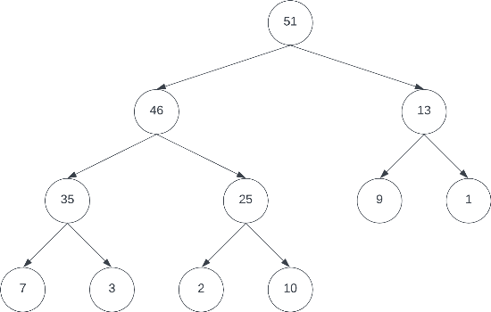
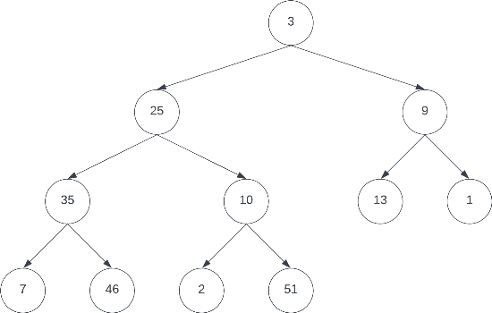
The initial binary tree is on the left, the initial heap is on the right.

The array form of the initial heap is (51,46,13,35,25,9,1,7,3,2,10).

The value in location of 5 of the initial heap is 9.

- After a single deletion (of the element at the heap root) and tree restructuring, what value is in location 5 of the new HEAP?

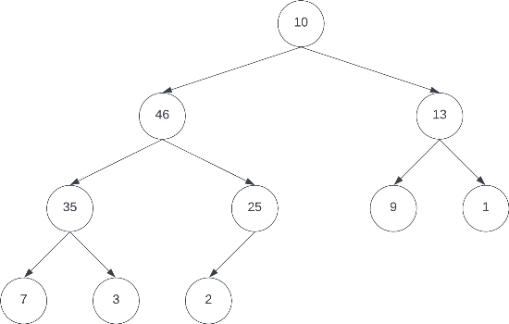
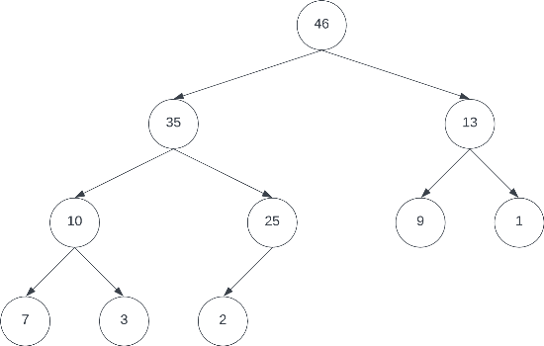
After deletion of 51 from the root, 10 will be swapped into the first position. The binary tree before restructuring is on the left, the heap after restructuring is on the right.

The array form of the new heap is (46,35,13,10,25,9,1,7,3,2).

The value in location of 5 of the new heap is still 9.

Problem 3 [20 pts]

Assume that we are given n pairs of items as input, where the first item is a number and the second item is one of three colors (red, blue, or yellow). Further assume that the items are sorted by number. Give an O(n) algorithm to sort the items by color (all reds before all blues before all yellows) such that the numbers for identical colors stay sorted.
For example: (1,blue), (3,red), (4,blue), (6,yellow), (9,red) should become (3,red), (9,red), (1,blue), (4,blue), (6,yellow).

Because the items are already sorted by number, an algorithm can easily be written that sorts the items by color in three passes. Because the question doesn’t specify if it must be an in-place sorting algorithm, I will assume the use of a second array is allowed. Pseudocode for such an algorithm is as follows:

Input: A: pairs of items, sorted by number, in an array; n: length of the array
Output: B: pairs of items, sorted by color and number, in a different array
Procedure:
i = 0 // A iterator
j = 0 // B iterator
For i=0, i < n, i++:
If A[i].color == “red”
B[j++] = A[i]
For i=0, i < n, i++:
If A[i].color == “blue”
B[j++] = A[i]
For i=0, i < n, i++:
If A[i].color == “yellow”
B[j++] = A[i]
Return B

This algorithm sorts the items by color while maintaining the order of numbers for identical colors by looping through the input array A and copying any red items to the output array B. This loop is then repeated for blue, then again for yellow. Because the each for loop executes n times, the for loops are O(n). Since there are only three colors to be sorted, the entire algorithm is 3*O(n) which is equal to O(n).

Problem 4 [10 pts]

You have a computer with only 2Mb of main memory. How do you use it to sort a large file of 500 Mb that is on disk?

The best way to sort a file that is larger than main memory is to use an external sort. This will break the file into smaller files until those files are smaller than the available memory, then sort the smaller files, then merge those files back into larger files while maintaining the sorted order of elements. This is the same procedure as merge sort, which is a recursive function that breaks down a list into a smaller list which will be sorted using the same algorithm. The key step is in merging the smaller files which are returned by the recursive calls into a larger sorted file.

Problem 5 [20pts]

Insert the keys <13, 19, 35, 71, 31, 6, 23, 4,98> into hash table of size m=13 using linear probing hashing. Here, h(k, i) =((k mod m) + i) mod m, i=0,1,2,….
How many times you increment i to resolve collisions?

hash_table( 0, 0, 0, 0, 0, 0, 0, 0, 0, 0, 0, 0, 0) // initial
hash_table(13, 0, 0, 0, 0, 0, 0, 0, 0, 0, 0, 0, 0) // insert 13
hash_table(13, 0, 0, 0, 0, 0,19, 0, 0, 0, 0, 0, 0) // insert 19
hash_table(13, 0, 0, 0, 0, 0,19, 0, 0,35, 0, 0, 0) // insert 35
hash_table(13, 0, 0, 0, 0, 0,19,71, 0,35, 0, 0, 0) // insert 71 (collision)
hash_table(13, 0, 0, 0, 0,31,19,71, 0,35, 0, 0, 0) // insert 31
hash_table(13, 0, 0, 0, 0,31,19,71, 6,35, 0, 0, 0) // insert 6 (collision x2)
hash_table(13, 0, 0, 0, 0,31,19,71, 6,35,23, 0, 0) // insert 23
hash_table(13, 0, 0, 0, 4,31,19,71, 6,35,23, 0, 0) // insert 4
hash_table(13, 0, 0, 0, 4,31,19,71, 6,35,23,98, 0) // insert 98 (collision x4)

There was a total of 7 collisions, so i must have been incremented 7 times to avoid the collisions.

Problem 6 [15 pts]

Suppose you have an unsorted array A of n elements and we want to know if A contains any duplicate elements. These elements are integers from the range 1, … , 2n.
Tell the asymptotic order T(n) of the worst-case running time for this solution. Try to find the efficient algorithm.

Assuming that space is not a concern, the most efficient algorithm for this problem is to create a hash table of size 2n with a simple hash where the key is equal to the bucket [h(k)=k]. Each element of the unsorted array A is inserted into the hash table, and duplicates are easily identified when there is a collision. Because the size of the hash table was selected so that collisions only occur when the elements are identical, each insertion operation will be O(1), and in the worst case where there are no duplicates each element will be inserted into the hash table, performing n*O(1) operations. Therefore, the worst-case running time of this algorithm is O(n).

Problem 7 [5pts]

If you are given a billion integers to sort, what algorithm would you use to sort them? How much time and memory would that consume?

For an input of this size, I would choose a sorting algorithm with worst-case time complexity O(n log n) since that is generally the best achievable time complexity for inputs of integers of unknown size (radix sort and count sort can offer better performance if the maximum element is small). Out of the sorting algorithms with O(n log n) time complexity, I would choose heap sort because it has the smallest spacy complexity since it is an in-place sorting algorithm. Therefore, I would choose heap sort which would take ~30 sec to sort the integers and consume one billion integer-sized chunks of memory.

